**SOFTWARE DESIGN DOCUMENT**

**1.INTRODUCTION**

**1.1 Purpose**

There are more than 10.000 different coins with different technologies and purposes. We wanted to build an application that easy to use yet effective to provide keeping track of multiple cryptocurrency assets. System will be a web application that gathers data from the third-party price monitoring systems and our application will make the user owned coins and their amounts are trackable in real-time with many useful insights.

**1.2 Scope**

The purpose of this application is to make it easier to follow the coins that change quickly. Our application is easy to use and will allow you to monitor the entire coin market in real time. Thus, instead of having to follow it manually, you can reach what you want by using this application. For example, users can follow the coins they want by opening a membership.

**1.3 Glossary**

|  |  |
| --- | --- |
| Term | Definition |
| Bitcoin | The first global, decentralized currency. |
| Bits | A sub-unit of one bitcoin. There are 1,000,000 bits in one bitcoin. |
| Blockchain | The authoritative record of every Bitcoin transaction that has ever occurred. |
| BTC | An abbreviation for the bitcoin currency. |
| Cold Wallet | A Bitcoin wallet that is in cold storage (not connected to the internet). |
| Cryptocurrency | A type of currency that uses cryptography instead of a central bank to provide security and verify transactions. Bitcoin is the first cryptocurrency. |
| Sitemap | A sitemap is an outline of all the pages on a website. There are three different types of sitemaps: those used by web designers when planning a website, hierarchical listings intended for the human user, and structured listings intended for search engines. |
| Web app | It’s important to distinguish between mobile apps and web apps, as they are built differently. Native mobile apps are built for a specific platform, such as iOS for iPhone, and are installed and run on the device itself. Web apps, on the other hand, are accessed via the internet browser and will adapt to whichever device you’re viewing them. They’re not native to a specific system, nor do they need to be downloaded or installed. |

**2. Software Architecture**

**2.1. Architecture Design Approach**

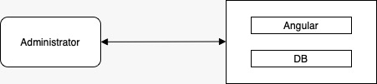

Figure 1

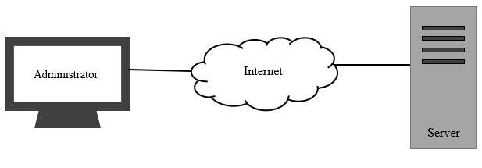

Figure 2

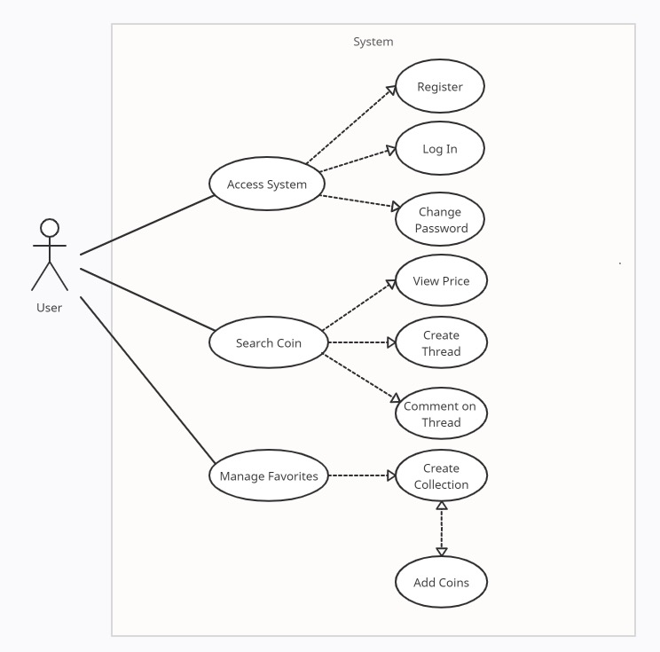

Figure 3

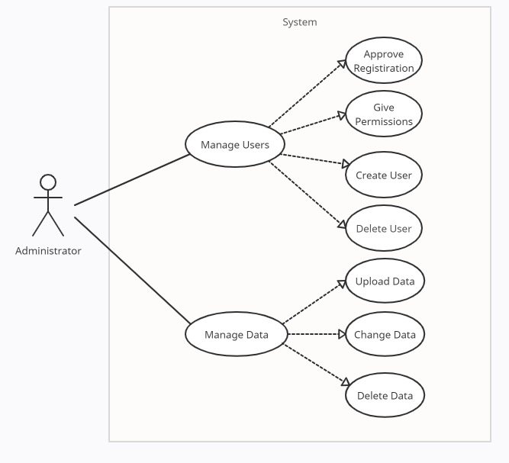

Figure 4

**3. User Interface Design**

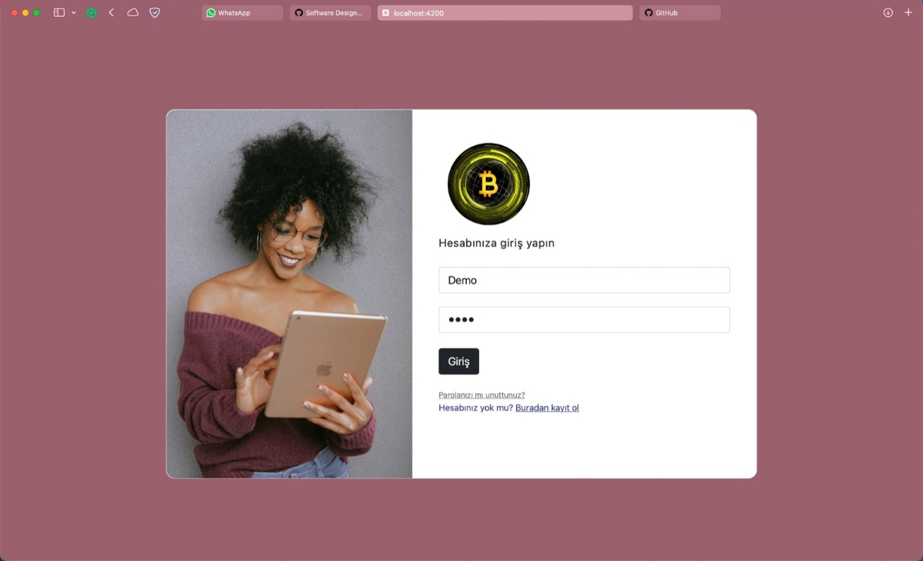

Figure 5: Login Page

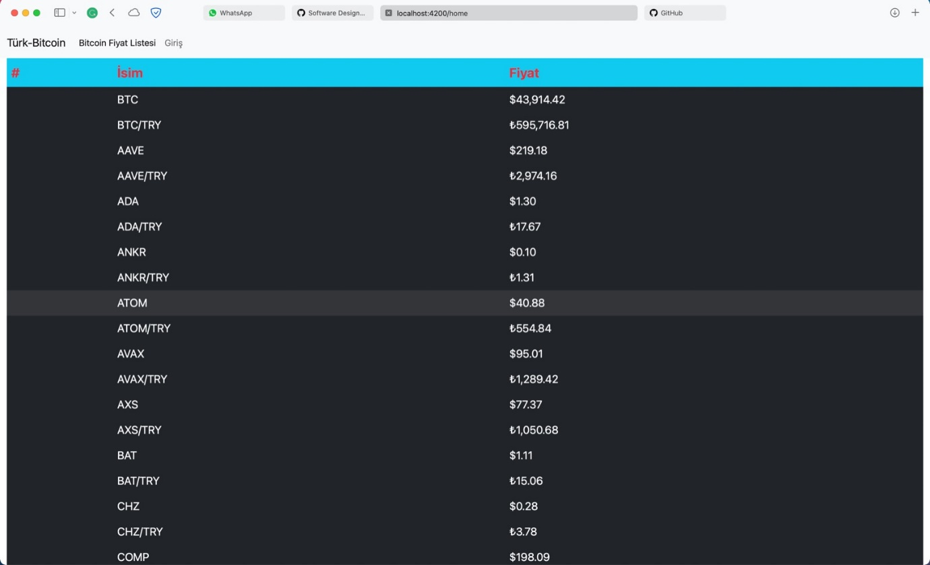

Figure 6: Coin Prices List Page

**References**

**[1]** https://help.coinbase.com/en/coinbase/getting-started/crypto-education/bitcoin-glossary

**[2]** https://www.kubera.com/blog/how-to-track-your-cryptocurrency-portfolio

**[3]** https://help.coinbase.com/en/coinbase/getting-started/crypto-education/bitcoin-glossary

**[4]** https://careerfoundry.com/en/blog/web-development/50-web-development-buzzwords-that-all-new-programmers-should-learn/

**[5]** https://creately.com/